| **Test Name** | | Search for a Physician Record | | | |
| --- | --- | --- | --- | --- | --- |
| **Use Case Tested:** | | Use Case – Search for a Physician Record | | | |
| **Test Description:** | | User find a record entered for a Physician  User navigates to Search tab and selects Search Physician, or selects Search Physician button from welcome page  User is presented with a list of physician records  User can search on all fields | | | |
| **Pre-conditions** | | User must login as an administrator  Physician records must exist | | | |
| **Post-conditions** | | Records are presented to user | | | |
| **Notes:** | |  | | | |
| **Result (Pass/Fail/Warning/Incomplete)** | |  | | | |
|  | **TEST STEP** | | **EXPECTED TEST RESULTS** | P | F |
|  | User selects “Search > Search Physician” from the menu bar or selects Search Physician button on Admin Home page | | A list of physician records is returned – using tab  A list of physician records is returned – using button | X  X |  |
|  | User enters a search for an Id | | Records meeting criteria are returned | X |  |
|  | User enters a search for a Surname | | Records meeting criteria are returned | X |  |
|  | User enters a search for a First Name | | Records meeting criteria are returned | X |  |
|  | User enters a search for a Provider Number | | Records meeting criteria are returned | X |  |
|  | User enters a search for a Comment | | Records meeting criteria are returned | X |  |

|  |  |  |  |  |  |
| --- | --- | --- | --- | --- | --- |
| **Test Data Table** | | | | | |
|  | **1** | **2** | **3** | **4** | **5** |
| Test – 1 | Id = 12 | Surname = how | First Name = mat | Provider No = nj | Comment = co |
| Test – |  |  |  |  |  |
| Test – |  |  |  |  |  |
|  |  |  |  |  |  |

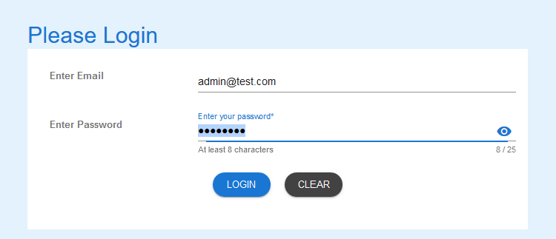

Login as administrator

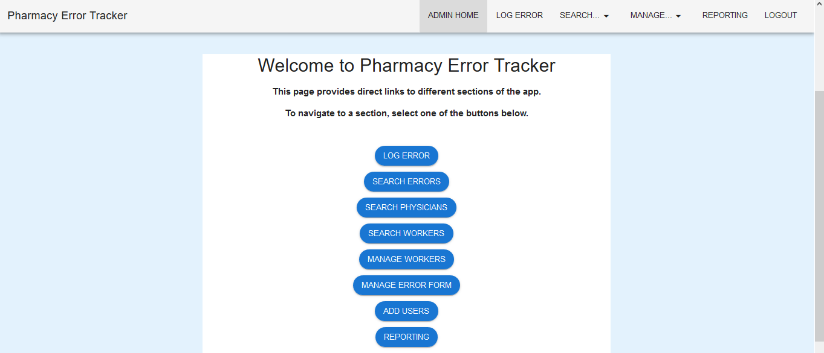

Welcome page for Administrator

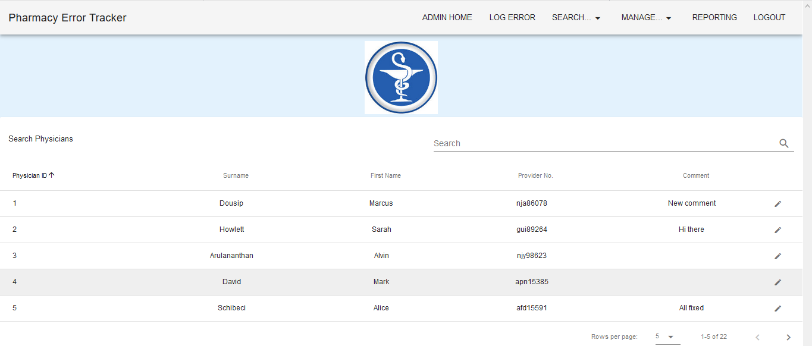

Using Search Tab – list of Physician records presented



Button – Search Physicians – selected

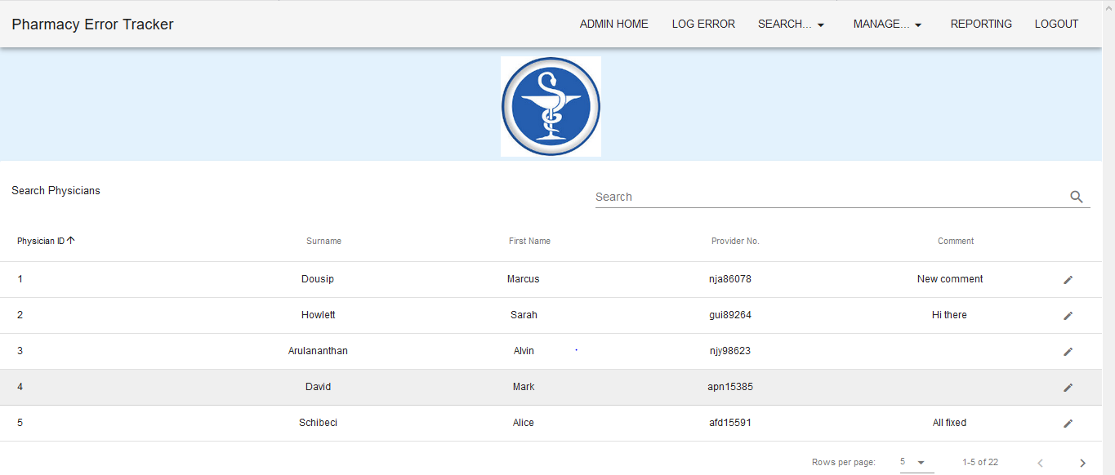

List of Physician records presented

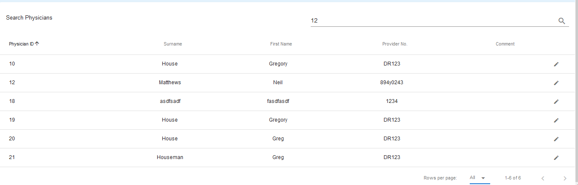

All records containing “12” returned

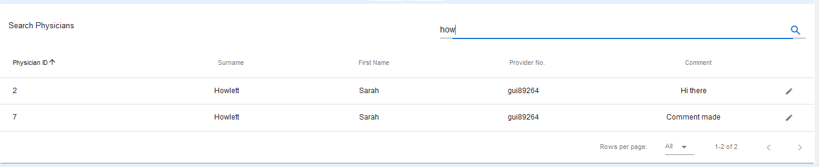

All records containing “how” returned

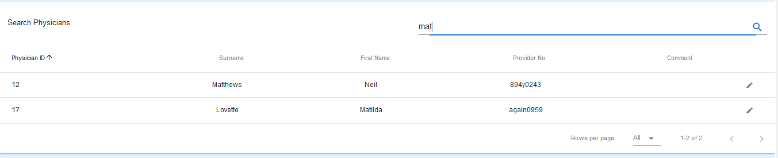

All records containing “mat” returned

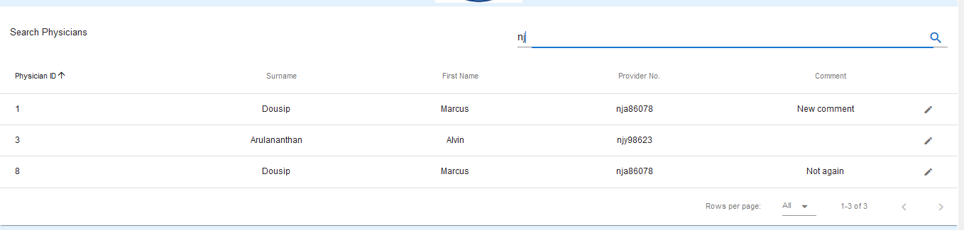

All records containing “nj” returned

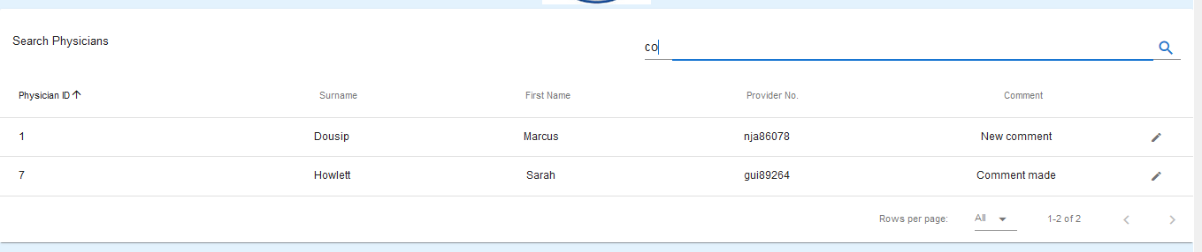

All records containing “co” returned